**InetAddress**

Inet Address encapsulates both numerical IP address and the domain name for that address. Inet address can handle both IPv4 and Ipv6 addresses. Inet Address class has no visible constructor. To create an inet Address object, you have to use **Factory methods**.

Three commonly used Inet Address factory methods are.

1. static *InetAddress* **getLocalHost()** throws **UnknownHostException**
2. static *InetAddress* **getByName** (*String hostname*) throws **UnknownHostException**
3. static *InetAddress[ ]* **getAllByName** (*String hostname*) throws **UnknownHostException**

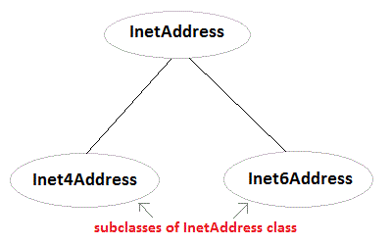

**Example using InetAddress class**

import java.net.*;

class Test

{

public static void main(String[] args)

{

**InetAddress address = InetAddress.getLocalHost()**;

System.out.println(address);

address = **InetAddress.getByName**("www.netparam.com");

System.out.println(address);

InetAddress sw[] = **InetAddress.getAllByName**("www.netparam.com");

for(int i=0; i< sw.length; i++)

{

System.out.println(sw[i]);

}

}

}

**Output:**

Welcome-PC/59.161.87.227

www.netparam.com/74.125.236.115

www.netparam.com/74.125.236.116

www.netparam.com/74.125.236.112

www.netparam.com/74.125.236.113

www.netparam.com/74.125.236.114

www.netparam.com/2404:6800:4009:802:0:0:0:1014